H.T No
Regulations:
A20

Sreenidhi Institute of Science and Technology
(An Autonomous Institution)
Code No: 8AC07 Date: 07-July-2023 (FN)

B.Tech III-Year II- Semester External Examination, July - 2023 (Regular)
LINEAR CONTROL SYSTEMS (ECE)

Time: 3 Hours Max.Marks:70

Note: a) No additional answer sheets will be provided.
b) All sub-parts of a question must be answered at one place only, otherwise it will not be valued.
c) Missing data can be assumed suitably.

Bloom's Cognitive Levels of Learning (BCLL)

Remember | L1 | Apply | L3 | Evaluate | L5
Understand | L2 | Analyze | L4 | Create | L6

Part - A Max.Marks:20
Answer all QUESTIONS

 |  | BCLL | CO(s) | Marks
1 | Distinguish between open loop and closed loop system. | L1 | CO1 | [2M]
2 | List the standard test signals. | L1 | CO2 | [2M]
3 | What are the limitations of Routh’s stability? | L1 | CO3 | [2M]
4 | What are frequency domain specifications? | L1 | CO4 | [2M]
5 | Draw the polar plot for G(s) H(s) = (1+2s) / (1+3s). | L2 | CO5 | [2M]
6 | Mention any four advantages of state variable representation. | L1 | CO6 | [2M]
7 | What is a signal flow graph? | L1 | CO1 | [2M]
8 | What are the advantages of frequency domain analysis? | L1 | CO4 | [2M]
9 | What is the difference between polar plot and Nyquist plot? | L1 | CO5 | [2M]
10 | What is meant by state in control system? | L1 | CO6 | [2M]
Part – B Max.Marks:50
ANSWER ANY FIVE QUESTIONS. EACH QUESTION CARRIES 10 MARKS.

 |  |  | BCLL | CO(s) | Marks
11. |  | For the mechanical system shown in Fig, determine the transfer functions 𝐗𝟏(𝐬)/ F(𝐬) & 𝐗𝟐(𝐬)/𝐅(𝐬)  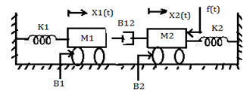 | L3 | CO1 | [10M]
12. |  | A unity feedback system has a forward path transfer function  G(s) = 8/s(s+2). Find the value of  i)damping ratio,  ii)undamped natural frequency of the system,  iii)percentage over shoot,  iv)peak time and  v) settling time. | L3 | CO2 | [10M]
13. |  | Develop the root locus of the open loop transfer function given below:  G(s)H(s) = K / s(s+2)(s+4) | L4 | CO3 | [10M]
14. |  | Develop the Bode plot for a system and find gain cross over frequency.  G(s) =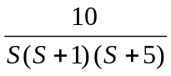 | L4 | CO4 | [10M]
15. | a) | Draw the Nyquist plot for the system whose open loop transfer function is, G(s)H(s) = 𝑲 / 𝑺(𝑺+𝟐) (𝑺+𝟏𝟎) .  Determine the range of K for which closed loop system is stable. | L4 | CO5 | [5M]
 | b) | Write a short note on Nyquist plot. |  | CO5 | [5M]
16. | a) | State the properties of State Transition Matrix. | L1 | CO6 | [5M]
 | b) | Diagonalize the system matrix given below.  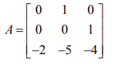 |  | CO6 | [5M]
17. | a) | Compute C/R ratio for a given block diagram shown in figure.  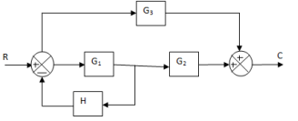 | L4 | CO1 | [4M]
 | b) | List the time domain specifications? | L2 | CO2 | [3M]
 | c) | Discuss the difficulties in RH stability criterion? | L2 | CO3 | [3M]
18. | a) | Sketch the magnitude bode plot for the system having the following transfer function:  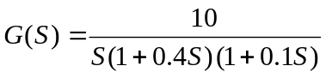 | L3 | CO4 | [4M]
 | b) | Explain phase lag compensator. | L2 | CO5 | [3M]
 | c) | Define:  i) State ii) State variables iii) State space representation. | L1 | CO6 | [3M]

-- 00 -- 00 –

